**INVETOTRACK**

**-WE KEEP THINGS TRACKED-**

**V1.0.0**

**(Basic User Guide)**

**IN PARTIAL FULFILLMENT IN DATA STRUCTURES AND ALGORITHM FINAL TERM**

Submitted and Developed by:

Melquizedek Felix

Submitted to:

Ferdinand Fernando

**OVERVIEW**

**Back end:** PHP

**Database:** SQL

**Front End:** HTML, CSS, JS, jQuery, MDBootstrap

**Components and Utilities:** jQuery Data Table and NPM

**CLIENT SIDE**

**WELCOME-** Requires Login, Automatically detects if an account is a user or staff.

**User Account**- Directed to Homepage (admin panel not accessible)

**Encoder, Senior Staff and System Admin**- Directed to Admin Panel (homepage still accessible)

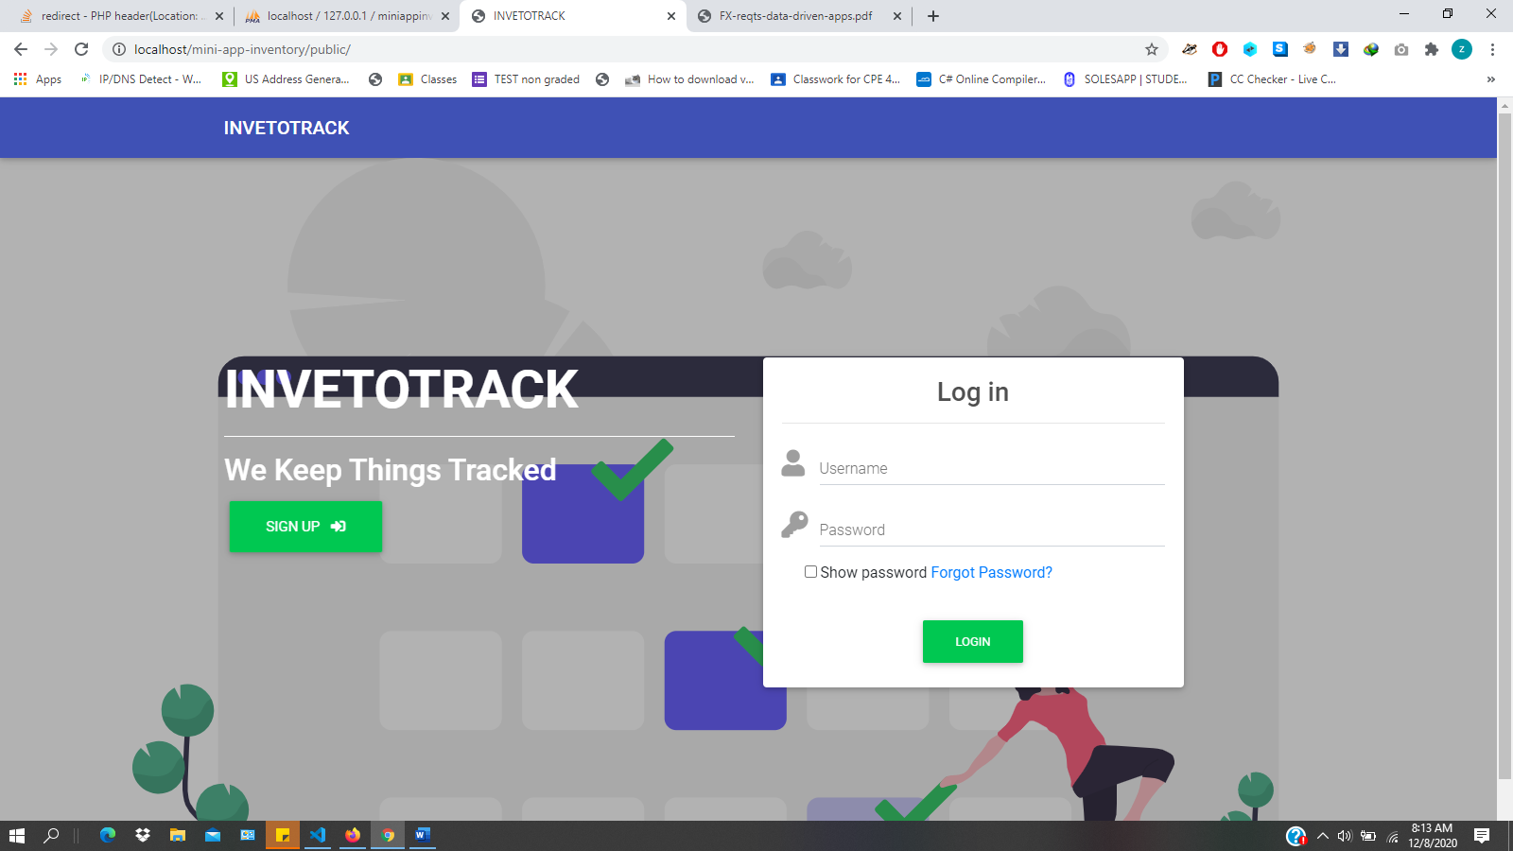

**HOME**

**Users**-can make purchases on the available products

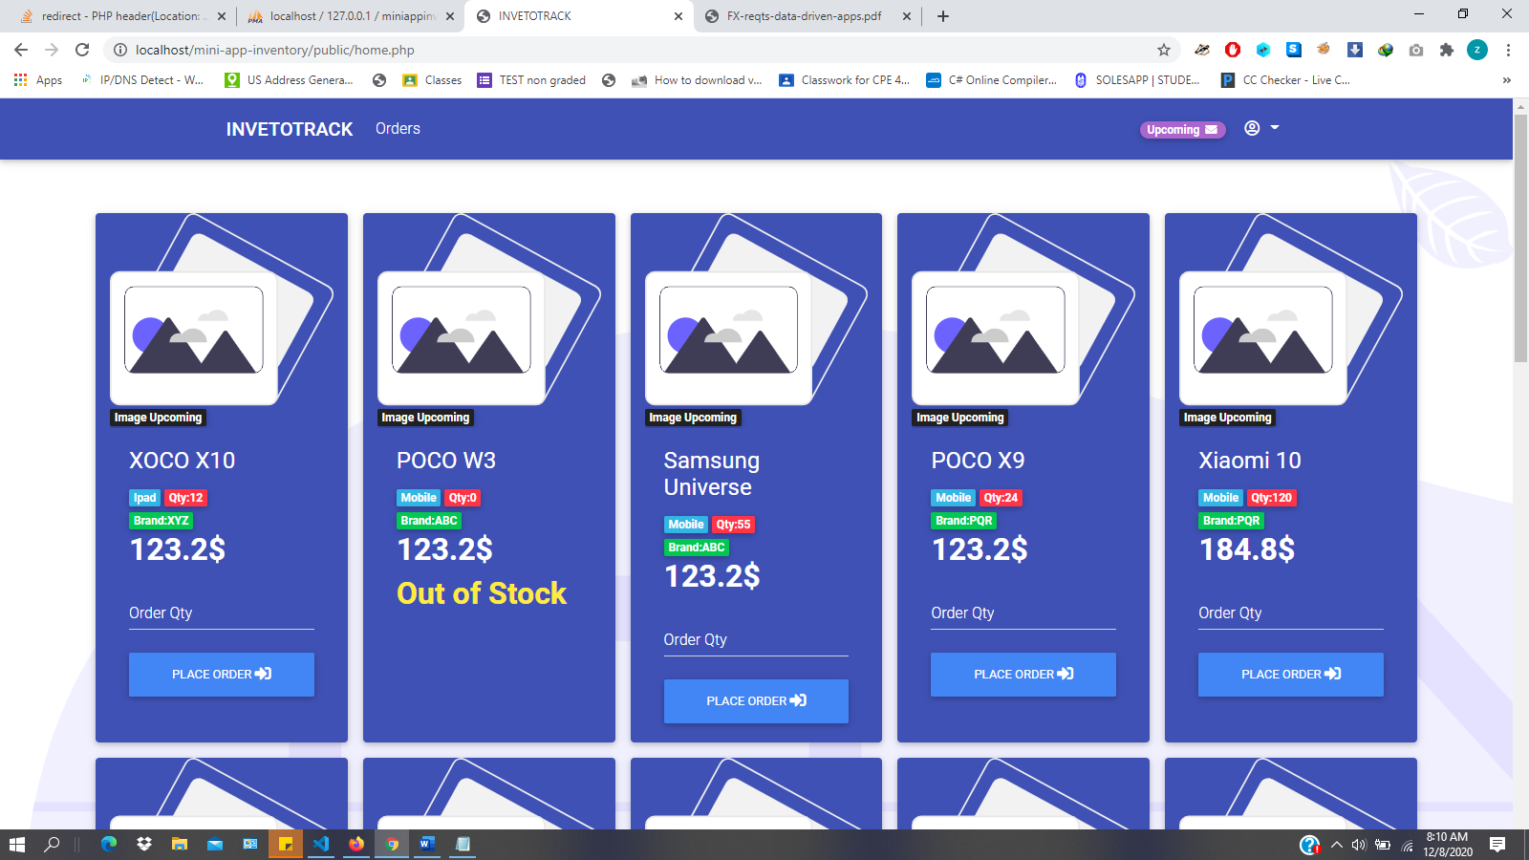

**ORDERS**

**Users**-can view and cancel all ordered products, payment can be done in COD

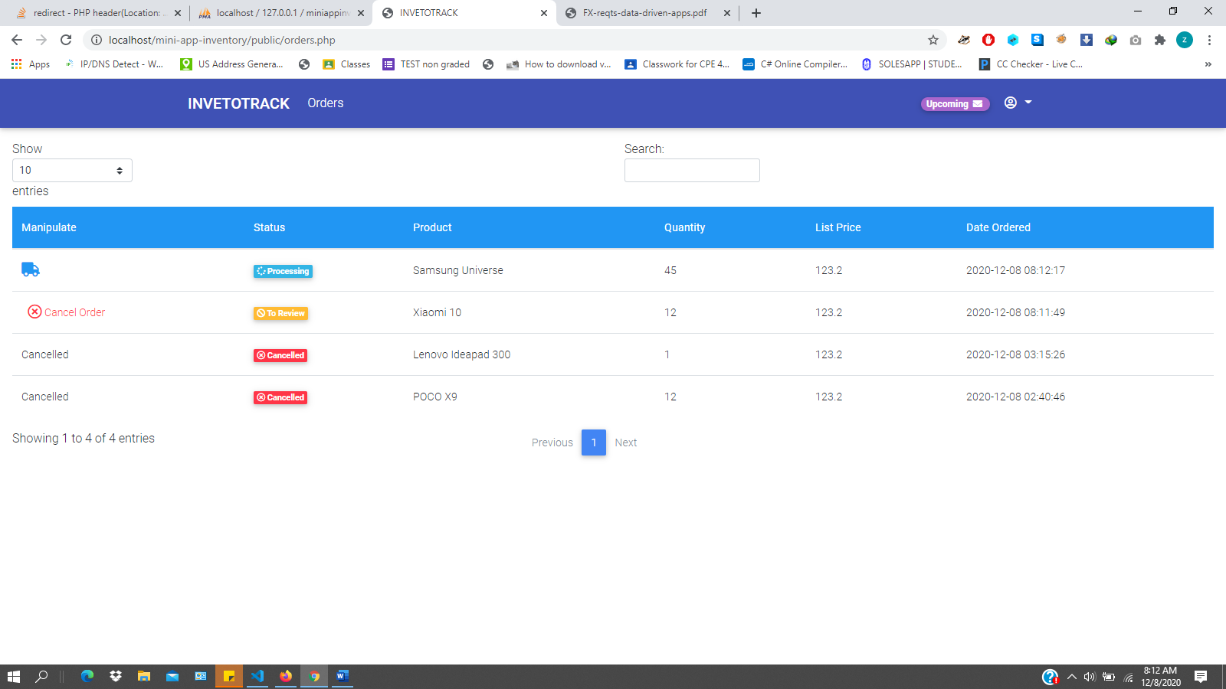

**ADMIN PANEL**

**ACCOUNT ROLES**

**User** – Place Order and Cancel

**Encoder** - Add and Print items from the app

**Senior Staff** – can do all the data processing except for maintaining the password

**System Admin** – No Restrictions

**DASHBOARD**

Gives an accurate real-time count of all data entered in specific tables

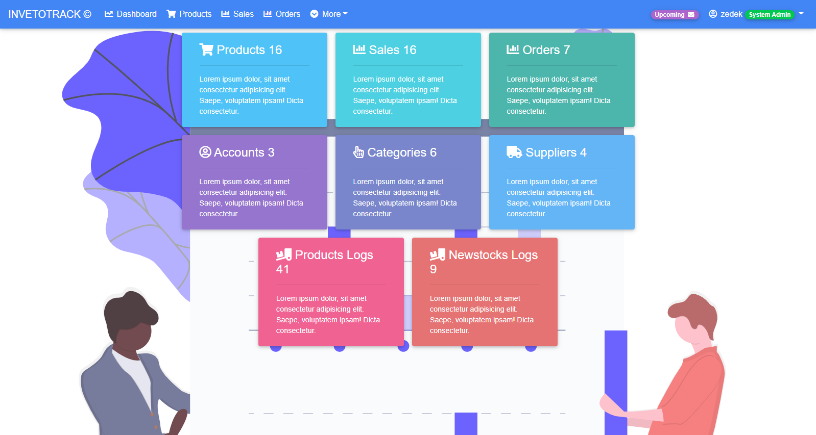

**PRODUCTS**

Add and Edit Product, Delete functionality is remove because product might be in use in other tables such as new stocks and sales, if a user purchase a product 1 it would directly reference from the products table for the information, if you delete product 1 , the product should be also deleted in the orders table because a customer cannot order a non-existing product likewise the company doesn’t process a non-existing or deleted product . However, this complication can be prevented by enabling or disabling the product if for sale or not, this would make the product available to the public or sales.

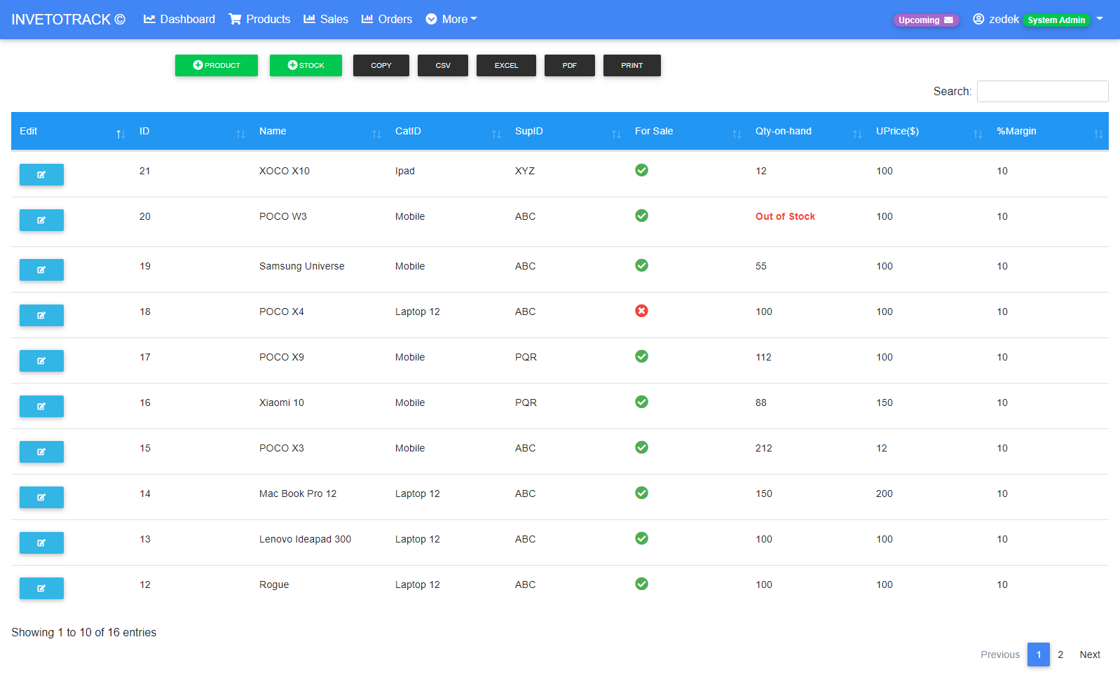

**SALES**

List all the products for sale, this are the ones that are seen in the public, there is no add, update and delete functionality because the table is made independent in new stocks and products table. 12% VAT is added.

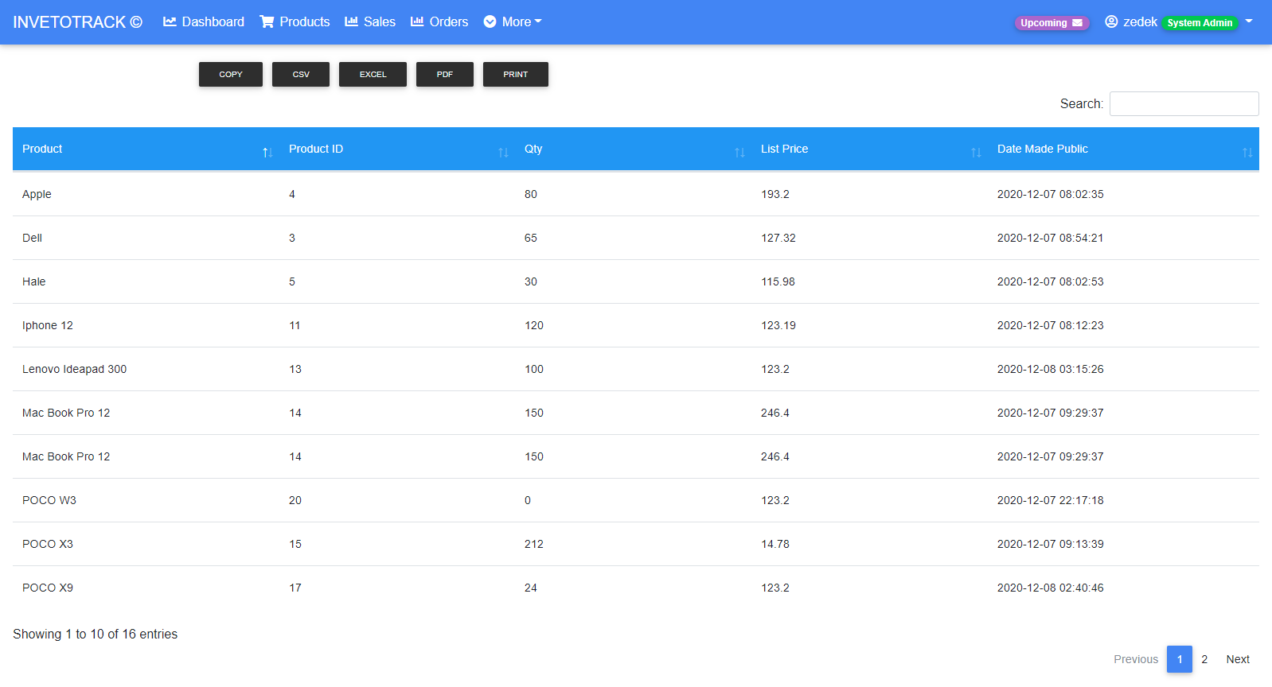

**ORDERS**

Keep track of the orders by the user, and set order state if it is done, processing, to review and cancelled the account id is automatically save in the table to keep track of the last person who modified it.

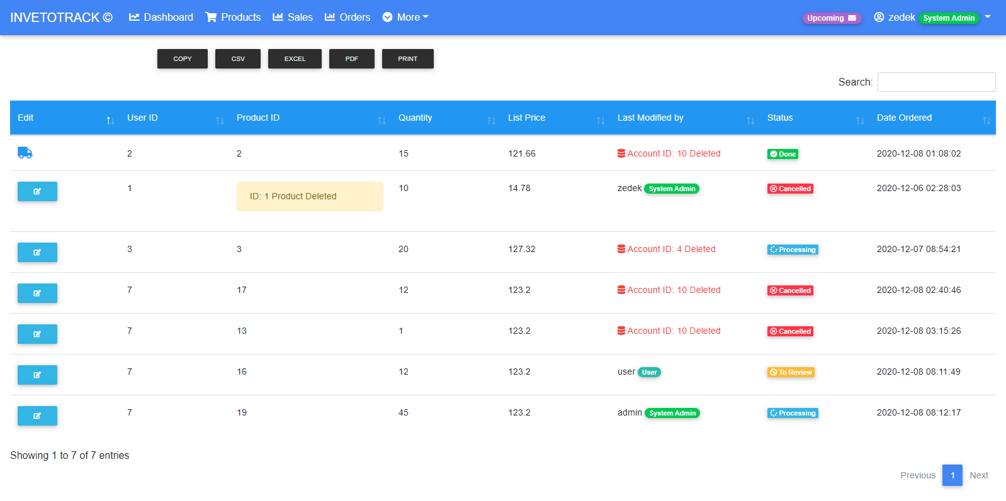

**NEWSTOCKS LOGS**

Logs all the new stock that comes in, price and qty is automatically updated in sales, orders (listPrice) and products (Unit Price)

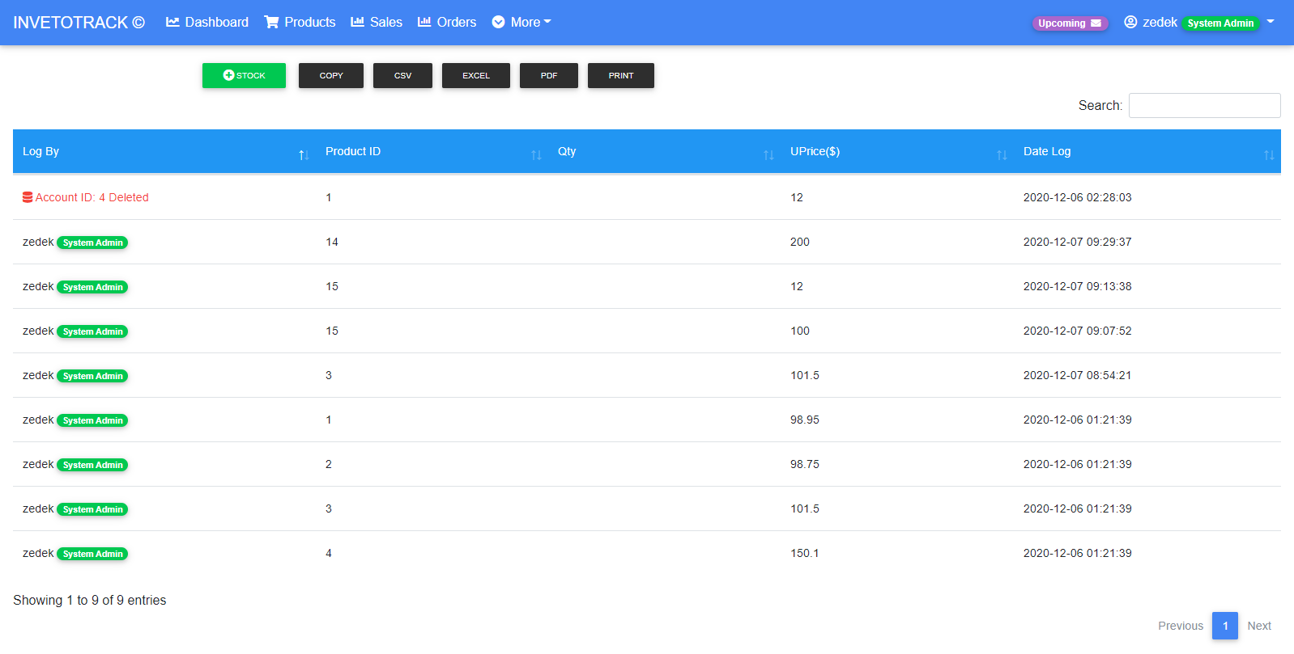

**PRODUCT LOGS**

Logs all the activity done in Products

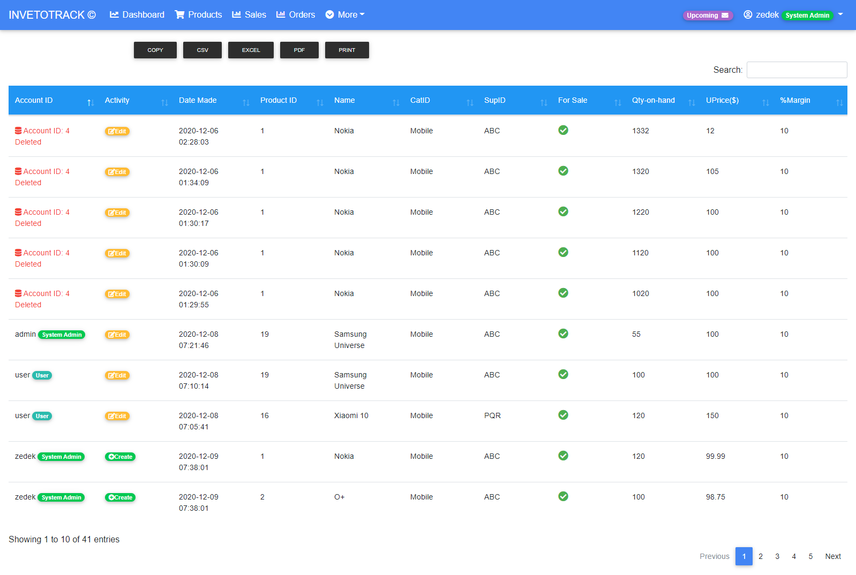

**CATEGORIES**

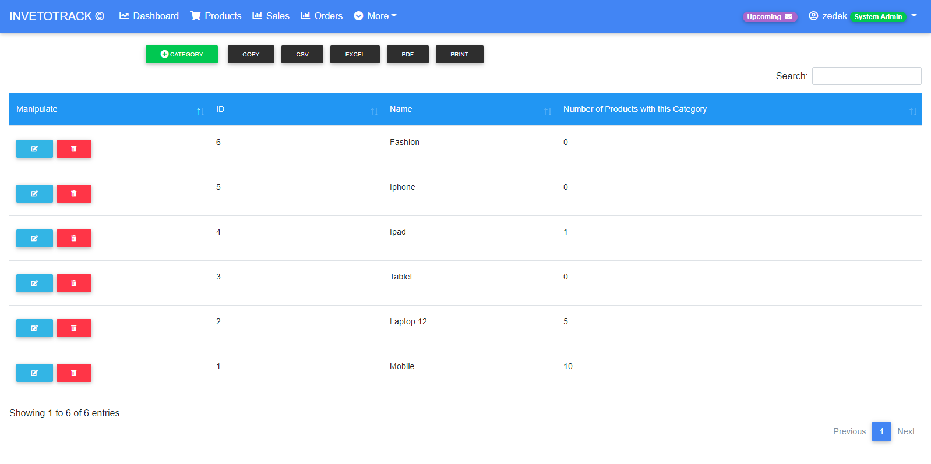

**SUPPLIERS**

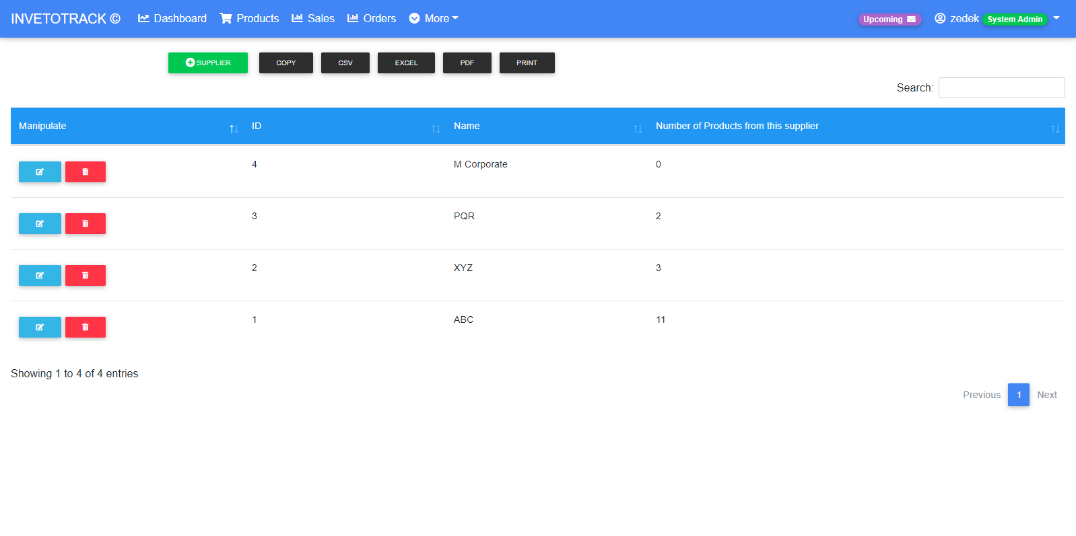

Categories and Suppliers has the same functionality delete is added, deleting a category or a supplier from the table might cause error in other but it still can be fixed by selecting new category for specific product.

**ACCOUNTS**

Create, Edit and Delete account. Password is hashed by php default password hash that uses a bcrypt algorithm.

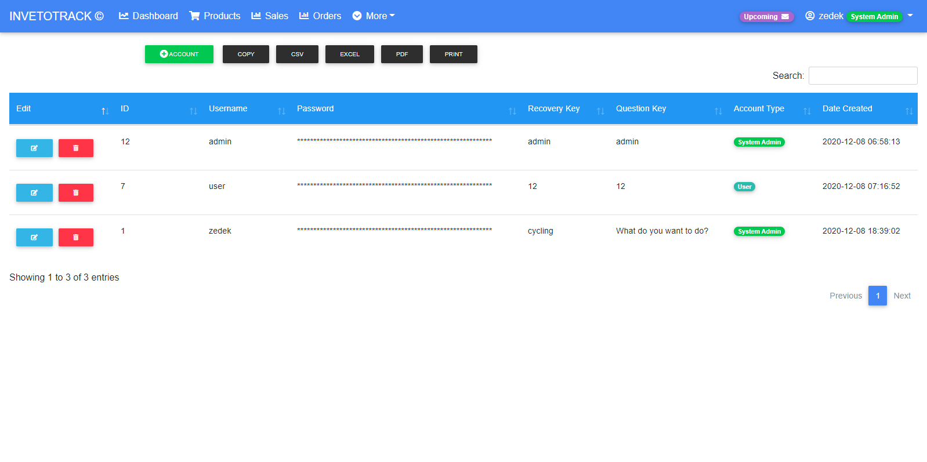

**UP AND RUNNING INVENTOTRACK**

**Requirements**

Download or git clone from the repository

1. Mini App: <https://github.com/user109436/mini-inventory-app-DSA-finals/tree/master>

2. Updated Browser

1. **Running in Local Machine**

**OS:** Windows, Linux && Ubuntu

**Recommended Server:** XAMMP or WAMP

**Alternative Server:** <https://www.slant.co/options/11127/alternatives/~xampp-alternatives>

* 1. Create a desired directory (app1 and etc) and Place the extracted files in the directory of the local server ( xampp or wamp )

usually **C:\xampp\htdocs**

* 1. Run xampp or wamp

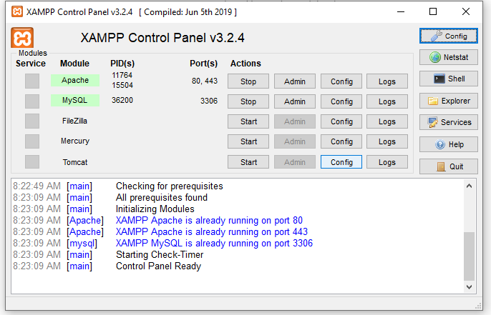

* 1. 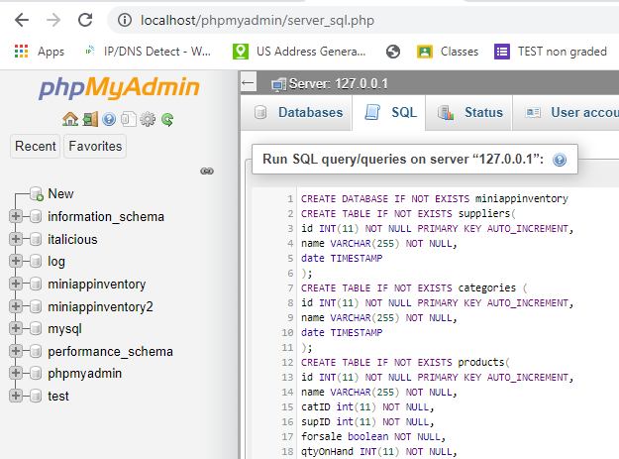Import **miniappinventoryRedesign.sql** in phpMyAdmin

1.4 In the URL bar type localhost/YourCreatedDirectory/public

In my case it is located in **localhost/mini-app-inventory/public/**

that’s it and you’re all done 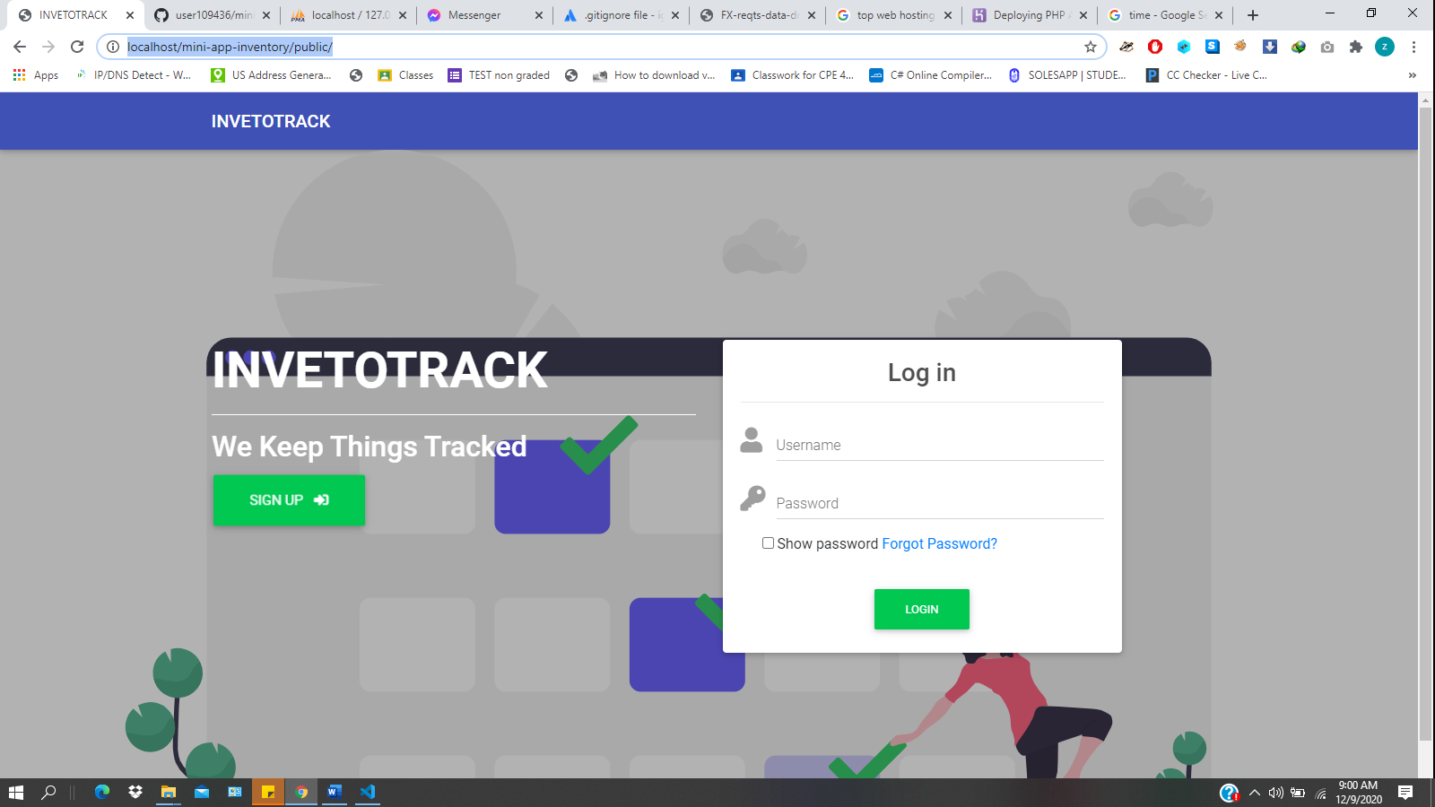

1. **Running Worldwide (Deployment)**

**Hosting Sites:** <https://www.websitebuilderexpert.com/web-hosting/php/>

**Recommended:** Heroku

**Deploy to Heroku:** <https://devcenter.heroku.com/articles/deploying-php#prerequisites>

**NOTES:** You should always keep all database configuration including the database design out in public to prevent the app from leaking sensitive information. Public folder are the ones available to your client.

**DATABASE SCHEMA**

